For Love & Country
Monitor
JASON 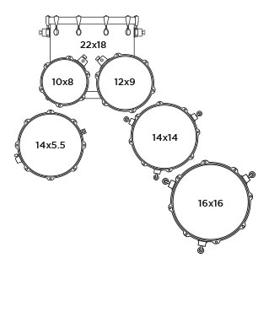
DI

Martin
Monitor

KEYBOARDS

Bass amp DI
DI

DI

GTR AMP

Dwayne
GTR AMP
Monitor

Dallas Guitar/Vocal
Lucas Bass / Vocal
Teryna Vocal
Monitor

Monitor
DI

Monitor

Input List
Input | Instrument | Notes | MIC or DI
1 | Kick |  | MIC
2 | Snare Top |  | MIC
3 | Tom 1 |  | MIC
4 | Tom 2 |  | MIC
5 | Tom 3 |  | MIC
6 | Tom 4 |  | MIC
7 | Hi Hat |  | MIC
8 | Drum Overhead L |  | MIC
9 | Drum Overhead R |  | MIC
10 | Drum Pad |  | DIRECT BOX
11 | Electric Guitar SL (Dwayne) |  | MIC
12 | Electric guitar SR (Dallas) |  | MIC
13 | Acoustic Guitar SR (Dallas) |  | DIRECT BOX
14 | OPEN
15 | Bass Guitar |  | DIRECT BOX
16 | Keyboard 1 |  | DIRECT BOX
17 | Keyboard 2 |  | DIRECT BOX
18 | OPEN
19 | Teryna Vocal | Boom Stand | WIRELESS MIC
20 | Lucas Vocal SL | Boom Stand | MIC
21 | Dallas Vocal SR | Boom Stand | WIRELESS MIC
22

